Code1: For Reflection across x-axis
#Reflection across x-axis
import matplotlib.pyplot as plt
# Original triangle points
x = [1, 3, 2,1]
y = [1, 1, 3,1]
# --- Reflection ---
# Across X-axis
y_x = [-i for i in y]
# --- Draw shapes ---
plt.plot(x , y , 'r', label='Original')
plt.plot(x , y_x , 'b', label='X-axis')
plt.legend()
plt.axis('equal')
plt.title("Reflection Transformation across x-axis Example")
plt.show()
output:
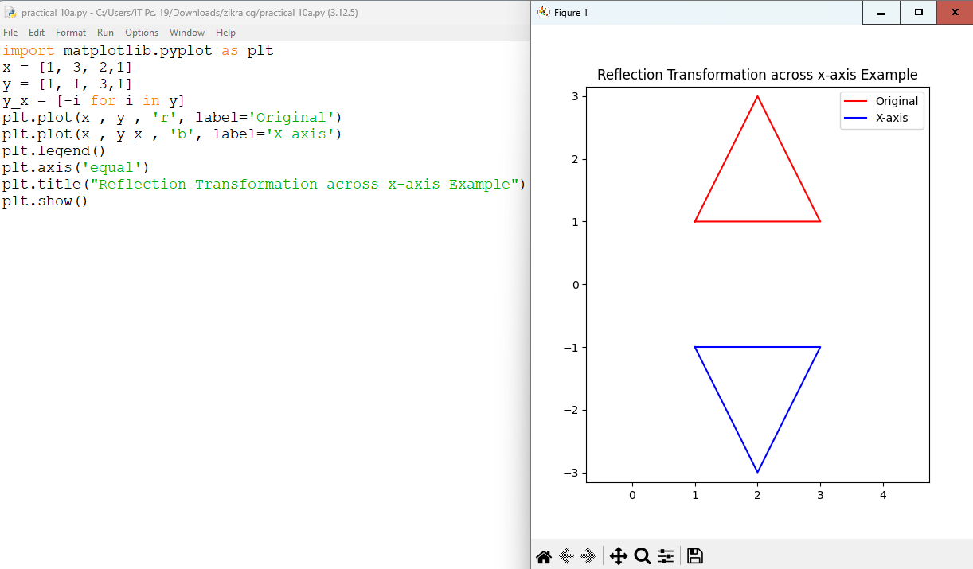
Code2:For Reflection across y-axis
#Reflection across y-axis
import matplotlib.pyplot as plt
# Original triangle points
x = [1, 3, 2,1]
y = [1, 1, 3,1]
# --- Reflection ---
# Across Y-axis
x_y = [-i for i in x]
# --- Draw shapes ---
plt.plot(x , y , 'r', label='Original')
plt.plot(x_y , y , 'g', label='Y-axis')
plt.legend()
plt.axis('equal')
plt.title("Reflection Transformation across y axis Example")
plt.show()
Output:
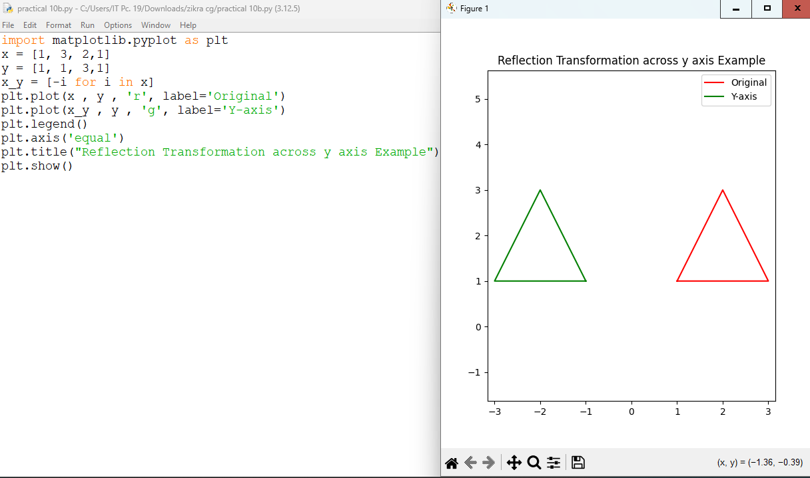
Code3:For Reflection across diagonal
#Reflection across diagonal
import matplotlib.pyplot as plt
# Original triangle points
x = [1, 3, 2,1]
y = [1, 1, 3,1]
# --- Reflection ---
# Across diagonal y = x
x_d, y_d = y, x
# --- Draw shapes ---
plt.plot(x , y , 'r', label='Original')
plt.plot(x_d , y_d , 'm', label='Diagonal')
plt.legend()
plt.axis('equal')
plt.title("Reflection Transformation across diagonal Example")
plt.show()
Output:
